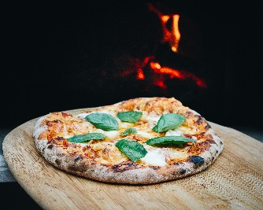

Pizza Co. Project

1. Find the total revenue from pizza_sales.

***Output***: Total pizza revenue is $817860.05…

1. Find the average order value amount spent per pizza order.

***Output***: The total order value amount of pizza sales is calculated by dividing the total revenue by the total of number of orders.

1. Find the total amount of pizza sold.

***Output***: The number or quantity of pizzas sold is 49, 574.

1. Find the total number of orders.

***Output:*** The number of unique orders placed is 21,350.

1. Find the average pizza per order.

***Output***: The average number of pizzas sold per order is calculated by dividing the total number of pizzas sold by the total number of orders.

1. Find the daily trend for total orders.

***Ouput:*** This query requires a DATENAME function which returns a character string. This query uses DISTINCT to find unique orders from total sales. The output is Grouped by days of the week.

1. Find the hourly trend for total orders.

***Output:*** Daily/DW ordersrequires the Datepart to track by hour.The total orders by hour can be grouped by hour in ASC order.

1. Find the types of pizzas sold from the total number of sales.

1. Find the Top 5 best sellers of pizza.

Output: The toal revenue is $49, 574 in sales.

***Output:*** This

